**Exp no11: Creation and execution of Procedures**

use db;

show tables;

select * from product;

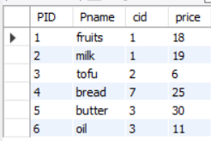

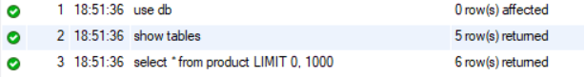

insert into product values(7,"veggies",6,15);

insert into product values(8,"flour",4,40);

insert into product values(9,"meat",3,13);

insert into product values(10,"spices",4,12);

select * from product;

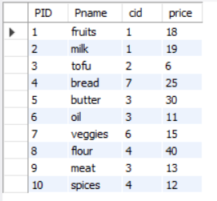

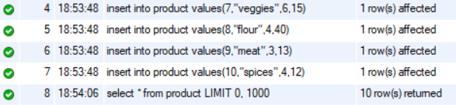

DELIMITER //

create procedure sam(in pnr numeric(33))

begin

select * from product;

end//

DELIMITER //

create procedure sam1(in pnr numeric(33))

begin

select * from product;

end //

DELIMITER //

create procedure sam3(in pnr numeric(30))

begin

select * from product where price = pnr;

end //

DELIMITER //

create procedure sam4(out pnr numeric(3))

begin

select count(*) into pnr from product;

end //



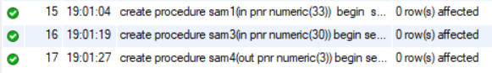

Call sam(33);

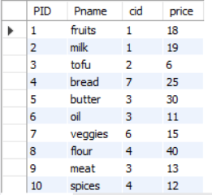

Call sam3(33);



Call sam4(@a);



Select @a;

